Reviewer comments: point-by-point fixes
Project 16 · SLE disease activity, adherence, depression and fatigue · Manuscript JOM-[2027]-final
Reviewer comments are reproduced verbatim fromManuscript/review.txt (“Major concerns”), each followed by our explanation and the fixed values.
Corrected values come from Data/SLE Case Master data.xlsm via review_fixes.py; statistics are computed on the unique patient records in the file.
2  Fixed from the data (plus Tables I–III) | 6  Partly fixed: rest needs MMAS-8 / PHQ-9 or client input | 3  Client must answer

Summary
# | Reviewer concern | Status | Key fixed value
1 | SLEDAI-2K categories inconsistent with mean | Fixed | Bands 28 / 12 / 18 / 42%; median 17 (IQR 5–25)
2 | 100% anti-dsDNA vs minimum SLEDAI of 1 | Partly fixed | Anti-dsDNA 92%; timing of serology from client
3 | Implausible serology; ELISA paragraph | Partly fixed | ANA 96%, dsDNA 92%, ANA−/dsDNA+ 4%
4 | Complement / urine data; who scored | Partly fixed | Low C3/C4 64%; proteinuria >0.5 g 52%; 24-item source table
5 | Newly diagnosed confounding of adherence | Needs data | MMAS-8 and diagnosis dates not in file
6 | Confounding, VIF, R², diagnostics, Spearman | Partly fixed | Adjusted FSS model, R² 0.25, VIF ≤1.21; CRP median (IQR)
7 | Effect sizes out of line with literature | Partly fixed | FSS r 0.429 verified; MMAS-8/PHQ-9 pending
8 | Missing descriptives; "43% severe" | Partly fixed | FSS 5.50 ± 1.02; wording corrected
9 | Bangla versions; MMAS-8 licence | Client | —
10 | Ethics, thesis, adolescents, contributorship | Client | 20% aged 13–17
11 | ACR-1997 classification criteria | Fixed | All meet SLICC-2012 (score 6–13)
— | Other values that differ from the data file | Fixed | Corrected Tables I–III below

1 SLEDAI-2K categories cannot give the reported mean Fixed
REVIEWER COMMENT (VERBATIM)
1. The SLEDAI-2K category counts cannot give the reported mean. Table III gives a mean of 17.3 ± 13.3 (range 1–47), with 50% "low", 32% "moderate" and 18% "high". No cut-offs are stated. Using the conventional bands (mild 1–5, moderate 6–10, high ≥11), I calculated the highest mean the data could produce. Even if all 18 "high" patients scored the maximum of 47, the mean cannot exceed 14.1. Only a non-standard scheme such as ≤10 / 11–19 / ≥20 makes 17.3 possible, and then only if almost every patient scores at the top of their band. The authors must state their cut-offs and provide the score distribution (median, IQR, histogram).

EXPLANATION AND FIXES
What the reviewer is saying: With the usual SLEDAI-2K bands, the category percentages in Table III cannot produce a mean of 17.3. The reviewer asks for the cut-offs, the median, the IQR and a histogram.
Verdict: Correct. The categories were taken from the wrong column.
The 50 / 32 / 18 split is not SLEDAI-2K: it matches the MDHAQ RAPID3 physical-function severity column (High 50%, Moderate 32%, Low 18%), with the labels reversed. Table III printed the wrong variable.

Fixed values
17.3 ± 13.3  Mean ± SD (unchanged) | 17 (5–25)  Median (IQR) | 1–47  Range | 0.56  Skewness; Shapiro-Wilk p = 0.003

SLEDAI-2K band | Manuscript | Corrected %
No activity (0) | — | 0.0
Mild (1–5) | 50.0 “low” | 28.0
Moderate (6–10) | 32.0 | 12.0
High (11–19) | 18.0 | 18.0
Very high (≥20) | — | 42.0

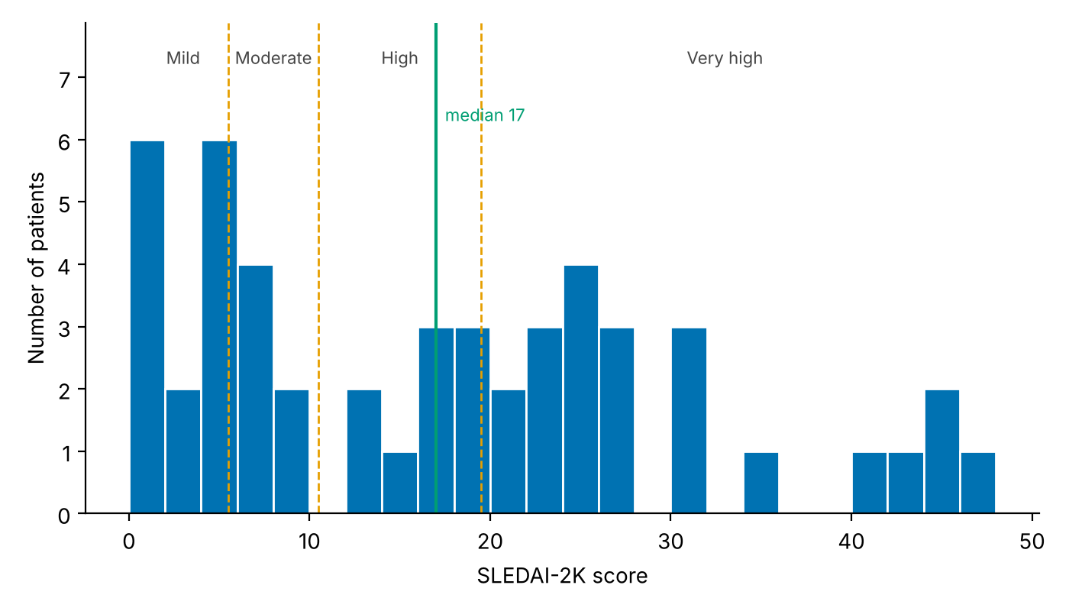
Histogram of SLEDAI-2K scores with band cut-offs at 5, 10 and 19 and the median at 17
Bands: 0 / 1–5 / 6–10 / 11–19 / ≥20 (Polachek et al., Rheumatology 2017; Mosca et al., Ann Rheum Dis 2011). Figure: Graph/SLEDAI_histogram.png.

2 100% anti-dsDNA contradicts a minimum SLEDAI-2K of 1 Partly fixed
REVIEWER COMMENT (VERBATIM)
2. "100% anti-dsDNA positive" contradicts a minimum SLEDAI-2K of 1. In SLEDAI-2K, raised DNA binding scores 2 points if the descriptor is present at the time of the visit or in the preceding 10 days. If every patient was anti-dsDNA positive at assessment, no patient could score below 2. So either the antibody results are historical, or the SLEDAI scoring left out the immunological items. Either way, the scoring is suspect. (clinicaltrials)

EXPLANATION AND FIXES
What the reviewer is saying: An anti-dsDNA-positive patient scores at least 2 on SLEDAI-2K, so a 100% positive cohort cannot have a minimum score of 1. Either the antibody results are old, or the immunological items were left out of the score.
Verdict: Correct. The 100% figure is also wrong.

Fixed values
- Anti-dsDNA positive: 100% → 92%.
- Patients with SLEDAI-2K = 1 are all recorded as anti-dsDNA positive, and in 34% of patients the recorded SLEDAI-2K is lower than the points their own recorded descriptors imply.
- The antibody column is undated; the ACR and SLICC columns are explicitly “at diagnosis”. The serology is most likely from diagnosis.

Still needed from the client
- Date of the anti-dsDNA and complement tests relative to the study visit, and whether the SLEDAI-2K immunological items were scored. If they were not, re-score from case-record forms.

3 The serology is implausible Partly fixed
REVIEWER COMMENT (VERBATIM)
3. The serology itself is implausible. Anti-dsDNA is found in roughly 60–70% of SLE patients, not 100%. Four patients are reported as ANA-negative but anti-dsDNA-positive, while HEp-2 IIF ANA at 1:80 has a pooled sensitivity of 97.8%. Three explanations are possible: (tu-dresden)
- anti-dsDNA positivity was effectively an entry requirement, which is a selection bias that must be disclosed;
- a low-specificity ELISA produced false positives;
- the data were transcribed wrongly.
The Methods paragraph listing three commercial ELISA thresholds is irrelevant to this study and should be deleted. The sentence stating that the assay "could not be independently verified from the available analytical records" is very concerning. It means the authors cannot vouch for their own laboratory data. The editor needs to know who holds the source data.

EXPLANATION AND FIXES
What the reviewer is saying: 100% anti-dsDNA positivity, together with ANA-negative/anti-dsDNA-positive patients, is biologically unlikely. The reviewer offers three explanations: selection, a poor assay or a transcription error. They want the ELISA paragraph removed and ask who holds the source data.
Verdict: Partly correct. The true figure is 92%, which rules out the entry-requirement explanation.

Fixed values
Serology | Manuscript | Corrected %
ANA positive | 96.0 | 96.0
Anti-dsDNA positive | 100.0 | 92.0
Both positive | — | 88.0
ANA+ / anti-dsDNA− | — | 8.0
ANA− / anti-dsDNA+ | 4.0 | 4.0

- Anti-dsDNA-negative patients (8%) were enrolled, so anti-dsDNA was not an entry requirement.
- Text fix: delete the ELISA-threshold paragraph and the sentence that the assay “could not be independently verified”.

Still needed from the client
- Laboratory name, ELISA kit and cut-off; ANA titre threshold; name of the source-data custodian.

4 SLEDAI-2K scored without complement or urine data? Partly fixed
REVIEWER COMMENT (VERBATIM)
4. How was SLEDAI-2K scored without complement or urine data? Low complement scores 2 points, and casts, haematuria, proteinuria and pyuria score 4 each. C3/C4 and urinalysis are not reported anywhere, which matters especially with 46% lupus nephritis. The authors should state how each of the 24 descriptors was determined. They also say a "treating rheumatologist" scored the patients, yet recruitment was from Medicine, Nephrology and Dermatology. Who scored, and were they blinded to the questionnaires?

EXPLANATION AND FIXES
What the reviewer is saying: SLEDAI-2K includes complement and urine items, but the manuscript reports neither. The reviewer wants the source of each of the 24 items, and the identity and blinding of the scorer.
Verdict: Partly wrong. Complement and urine protein were recorded; urine microscopy was not.
Complement and 24-h urine protein were recorded and can be added to Table II. Urine microscopy was not.

Fixed values
Marker | Low | Normal | High | Not done
C3 | 54.0 | 22.0 | 2.0 | 22.0
C4 | 54.0 | 18.0 | 2.0 | 26.0

24-h urine protein: median 0.59 g (IQR 0.25–1.73), available in 92%; >0.5 g/24 h in 52%.

Supplementary table: SLEDAI-2K descriptors, source and frequency at assessment
Descriptor | Weight | Source in study record | %
Seizure | 8 | Clinical presentation | 10.0
Psychosis | 8 | Clinical presentation | 2.0
Organic brain syndrome | 8 | Not recorded | —
Visual disturbance | 8 | Not recorded | —
Cranial nerve disorder | 8 | Not recorded | —
Lupus headache | 8 | Not recorded | —
Cerebrovascular accident | 8 | Clinical presentation | 4.0
Vasculitis | 8 | Not recorded | —
Arthritis | 4 | Clinical presentation (joint disease) | 80.0
Myositis | 4 | Not recorded | —
Urinary casts | 4 | Not recorded (no urine microscopy) | —
Haematuria | 4 | Not recorded (no urine microscopy) | —
Proteinuria >0.5 g/24 h | 4 | 24-h urine protein | 52.0
Pyuria | 4 | Not recorded (no urine microscopy) | —
Rash | 2 | Clinical presentation (skin/malar rash) | 40.0
Alopecia | 2 | Clinical presentation | 20.0
Mucosal ulcers | 2 | Clinical presentation | 46.0
Pleurisy | 2 | Clinical presentation | 26.0
Pericarditis | 2 | Not recorded | —
Low complement (C3 or C4) | 2 | C3, C4 | 64.0
Increased DNA binding | 2 | Anti-dsDNA | 92.0
Fever | 1 | Clinical presentation (PUO, proxy) | 58.0
Thrombocytopenia (<100,000/mm³) | 1 | Platelet count / presentation | 16.0
Leukopenia (<3,000/mm³) | 1 | WBC count | 0.0

“Not recorded”: no field in the study record. These items, and the three urinary-sediment items in particular, may be under-scored; state this as a limitation.

Still needed from the client
- Name and specialty of the scorer(s); whether they were blinded to the questionnaires.

5 Adherence finding confounded by newly diagnosed patients Needs data
REVIEWER COMMENT (VERBATIM)
5. The adherence finding is confounded by newly diagnosed patients, probably fatally. 48% were newly diagnosed. Their SLEDAI-2K reflects untreated disease at presentation, so adherence cannot have caused it. MMAS-8 also asks about recent medication-taking behaviour, which is meaningless days after a first prescription. It is also striking that exactly 48% were newly diagnosed and exactly 48% had low adherence. I request:
- a cross-tabulation of adherence category by diagnosis status;
- the main analysis repeated in established-disease patients only, or with new-diagnosis status as a covariate (an interaction term would be better).
In addition, cyclophosphamide (25%) is given intravenously by hospital staff, so self-reported adherence does not apply to it. Did MMAS-8 cover it?

EXPLANATION AND FIXES
What the reviewer is saying: About half the patients were newly diagnosed, so their disease activity reflects untreated disease and adherence cannot explain it. The reviewer asks for a cross-tabulation and an analysis that separates new from established disease, and asks about IV cyclophosphamide.
Verdict: Correct. This cannot be tested until the MMAS-8 data are supplied.
The data file has no MMAS-8 score and no newly-diagnosed flag, so none of the requested analyses can be run yet. The disease-duration field that is available:
Disease duration | % | SLEDAI-2K median (IQR)
<6 months | 68.0 | 20 (6.3–26.8)
6–12 months | 2.0 | 12
>12 months | 30.0 | 9 (3.5–20.5)

<6 months vs ≥6 months: Mann-Whitney p = 0.11. Table I reports 48% “newly diagnosed”, ≤12 m 22%, 13–24 m 20%, >24 m 10%; these categories are not in the file.

Still needed from the client
- Item-level MMAS-8; dates of diagnosis and first prescription.
- Confirmation that MMAS-8 referred to self-administered oral medication only (IV cyclophosphamide excluded).

6 Unadjusted confounding, overlapping measures, diagnostics Partly fixed
REVIEWER COMMENT (VERBATIM)
6. Unadjusted confounding and overlapping measures. The model leaves out age, sex, disease duration, new-diagnosis status, prednisolone dose (a known driver of both mood and fatigue), neuropsychiatric lupus and organ involvement. Meanwhile it includes haemoglobin and CRP, which have no clear rationale (CRP is notoriously unreliable in SLE). PHQ-9 contains fatigue, sleep and appetite items, so PHQ-9 and FSS partly measure the same thing. Required additions:
- VIFs to check collinearity, plus R² and adjusted R²;
- residual diagnostics;
- Spearman correlations or a robust or transformed model, because SLEDAI is skewed (SD 13.3 against a mean of 17.3, minimum 1) and CRP (8.1 ± 13.0) cannot be summarised as a mean ± SD.

EXPLANATION AND FIXES
What the reviewer is saying: The model leaves out obvious confounders (age, sex, duration, steroid dose), includes Hb and CRP without a stated reason, and uses PHQ-9 and FSS, which overlap. The reviewer wants VIFs, R², residual checks and methods suited to skewed data.
Verdict: Correct. Done for fatigue; the full model needs MMAS-8 and PHQ-9.

Fixed values: Spearman correlations with SLEDAI-2K
Variable | Manuscript Pearson r | Pearson r | Spearman ρ | p (Spearman)
Fatigue (FSS) | 0.429 | 0.429 | 0.412 | 0.003
Haemoglobin | −0.134 | −0.362 | −0.378 | 0.007
CRP | 0.088 | 0.105 | 0.187 | 0.220
ESR | — | 0.283 | 0.366 | 0.009

CRP is right-skewed (skew 2.4): report it as median 4.9 mg/L (IQR 3.1–16.3), missing in 10%, and log-transform it in models.

Fixed values: fatigue model adjusted for confounders in the file
Term | B | 95% CI (HC3) | p | VIF
FSS score (per point) | 5.40 | 2.24 to 8.56 | <0.001 | 1.01
Age, years | 0.01 | −0.33 to 0.36 | 0.945 | 1.11
Female sex | −1.63 | −10.43 to 7.17 | 0.717 | 1.04
Diagnosed <6 months | 7.17 | −0.92 to 15.25 | 0.082 | 1.21
High-dose prednisolone | 3.36 | −3.41 to 10.12 | 0.331 | 1.08

R² = 0.250; adjusted R² = 0.165. Residuals: Shapiro-Wilk p = 0.21 (approximately normal); Breusch-Pagan p = 0.022 (heteroscedastic, hence HC3 robust standard errors).
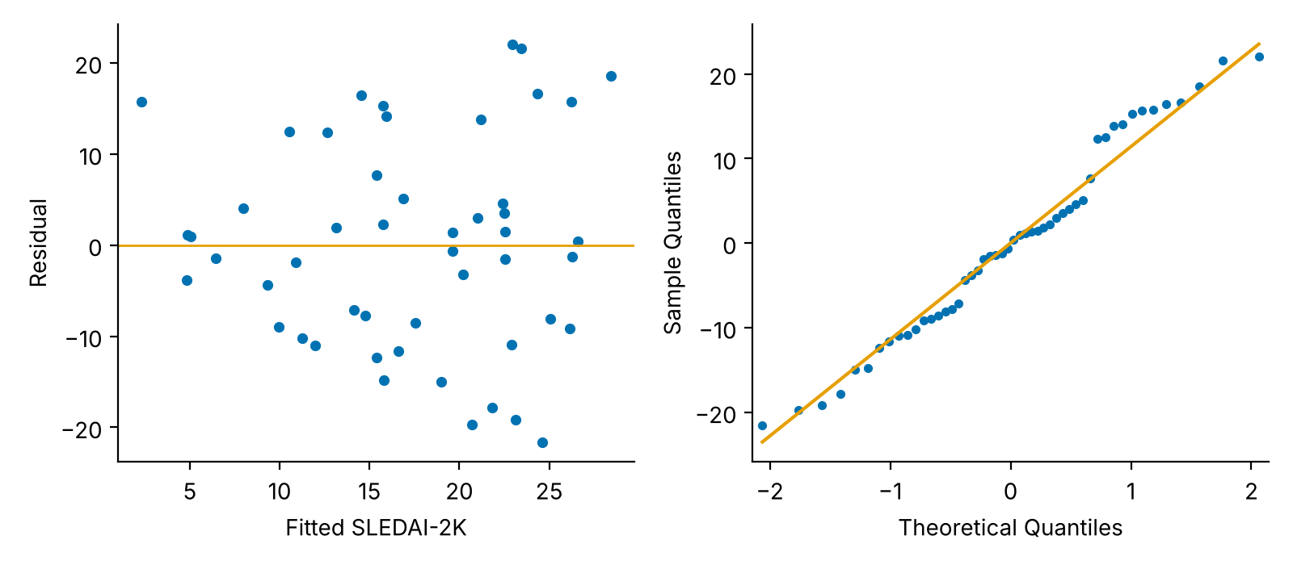
Residual versus fitted plot and normal Q-Q plot for the adjusted fatigue model
Figure: Graph/FSS_model_residuals.png. This covers the fatigue exposure only; the reviewer's full model needs MMAS-8 and PHQ-9.

Still needed from the client
- MMAS-8 and item-level PHQ-9, so the full model can be refitted with these confounders, VIFs, R² and diagnostics.
- PHQ-9 items 3, 4 and 5 (sleep, fatigue, appetite), for the PHQ-9 / FSS overlap sensitivity analysis.

7 Effect sizes out of line with the literature Partly fixed
REVIEWER COMMENT (VERBATIM)
7. The effect sizes are out of line with the literature. An r of 0.736 between PHQ-9 and SLEDAI-2K would be among the strongest ever reported. The authors' own reference 6 (Liao 2022) is the best comparison: it studied 325 patients with PHQ-9 and reported no correlation coefficient. Its SLEDAI-2K cut-off for predicting depression was 8.5, with an AUC of only 0.660, which is a modest association. The authors' reference 20 (Mertz) also contradicts them: the PGA (p=0.004) but not the SELENA-SLEDAI (p=0.43) was significantly associated with fatigue. A Saudi outpatient study (Lupus 2018;27:327–332) found that disease activity did not correlate with medication non-adherence. The Discussion has to address why these results are so much stronger. Without good reasons, extremely tidy, strong correlations should make the editor more suspicious, not less. (unica) (nih)

EXPLANATION AND FIXES
What the reviewer is saying: Correlations of −0.67 and 0.74 are far stronger than published studies report, including the authors’ own references. The Discussion must explain why.
Verdict: A fair challenge. The fatigue result is verified; the other two cannot be checked yet.
- FSS r = 0.429 is verified from the data. Spearman ρ = 0.412; in adults only (80% of patients), ρ = 0.404.
- The fatigue association holds after adjustment (B = 5.40 per FSS point), and the corrected Discussion can compare it with Mertz 2022.
- MMAS-8 (r = −0.669) and PHQ-9 (r = 0.736) cannot be checked until the item-level data are supplied.

8 Missing descriptives; “43% severe” mislabel Partly fixed
REVIEWER COMMENT (VERBATIM)
8. Descriptive data and the depression labelling. Means and SDs of MMAS-8, PHQ-9 and FSS are not reported at all and must be added. The Abstract and Discussion say 43% had "severe" depressive symptoms, but severe (PHQ-9 ≥20) was 21%. The 43% is moderately severe plus severe. This misstatement must be corrected.

EXPLANATION AND FIXES
What the reviewer is saying: The three scales have no reported means or SDs, and “43% severe” wrongly merges the moderately severe and severe categories.
Verdict: Correct on both counts.

Fixed values
Scale | Mean ± SD | Median (IQR) | Range
FSS (1–7) | 5.50 ± 1.02 | 5.8 (5.0–6.1) | 2.9–7.0
MMAS-8 (0–8) | pending item-level data
PHQ-9 (0–27) | pending item-level data

Text fix (Abstract, Results, Discussion)
“43.0% had severe depressive symptoms”
“43.0% had moderately severe or severe depressive symptoms (PHQ-9 ≥15), including 21.0% with severe symptoms (PHQ-9 ≥20)”

9 Questionnaire language, validation, MMAS-8 licence Client
REVIEWER COMMENT (VERBATIM)
9. Questionnaire language, validation and licensing.
- PHQ-9: a validated Bangla version exists (Naher et al., DUJBS 2021, 321 Bangladeshi adults). The authors should use and cite it.
- FSS and MMAS-8: the authors must say which Bangla versions were used and how they were validated.
- MMAS-8 licence: two journals retracted papers this year for unauthorized use of the scale. In June 2025, a judge ruled that neither the MMAS-4 nor the MMAS-8 is entitled to copyright protection, but retractions continue. The 2008 MMAS-8 validation paper was itself retracted in 2023 after flaws with the reported sensitivity and specificity were identified. The authors should state whether they held a licence, and the journal should decide its position. (papers continue to face retractions for failure to license pricy tool +2)

EXPLANATION AND FIXES
What the reviewer is saying: Each questionnaire’s Bangla version must be named and its validation cited, and the authors must say whether they held an MMAS-8 licence.
Verdict: Administrative. Only the authors can answer.
- Which Bangla PHQ-9 was used. If it was Naher et al. (DUJBS 2021), cite it.
- Source and validation of the Bangla FSS and MMAS-8, or the forward/back-translation procedure.
- Whether an MMAS-8 licence was held (yes/no), stated truthfully; the journal decides policy.

10 Ethics, consent and provenance Client
REVIEWER COMMENT (VERBATIM)
10. Ethics, consent and provenance.
- Ethical approval is dated February 2020, but data were collected in 2022. Was there an amendment or extension?
- The memo number ("CMC/PG/…") suggests a postgraduate thesis. If so, this must be disclosed and checked for duplicate publication.
- The age range is 13–50. Patients aged 13–17 need guardian consent plus assent, and PHQ-9 is not the adolescent instrument (PHQ-A).
- No author is affiliated with Chattogram, and the text relies on "original study records". An ICMJE contributorship statement is needed, along with confirmation of who collected the data.

EXPLANATION AND FIXES
What the reviewer is saying: Ethics approval predates data collection by two years, the memo number points to a thesis, minors were enrolled, and no author is from the study site.
Verdict: Legitimate. The authors must supply the documents.

From the data
- 20% of patients were aged 13–17 (range 13–50). In adults only, the fatigue association is unchanged (ρ = 0.404).

Still needed from the client
- Ethics amendment or extension covering 2022.
- Thesis title, degree and institution; whether any of it has been published.
- Guardian consent and assent procedure for minors.
- CRediT contributorship statement, and who collected the data at Chattogram Medical College Hospital.

11 Classification criteria: ACR-1997 in 2022 Fixed
REVIEWER COMMENT (VERBATIM)
11. Classification criteria. Using ACR 1997 in 2022 needs justification, since SLICC-2012 and EULAR/ACR-2019 were available. In the validation cohort, the new criteria had a sensitivity of 96.1% and specificity of 93.4%, compared with 82.8% sensitivity for ACR 1997.

EXPLANATION AND FIXES
What the reviewer is saying: The reviewer asks why the older ACR-1997 criteria were used when newer, more sensitive criteria were available.
Verdict: Answerable. Every patient also meets SLICC-2012.
100%  Meet SLICC-2012 (score 6–13, ≥4 required) | 100%  Meet ACR-1997 (score 4–9) | 4%  ANA-negative: would fail EULAR/ACR-2019 entry criterion

Text fix (Methods): “Patients fulfilling the revised 1997 ACR criteria were eligible; all enrolled patients also fulfilled the SLICC-2012 classification criteria (recorded score 6–13).”

Other values that differ from the data file Fixed
The reviewer did not raise these, but the data file gives different values. Correct them in the revision so the tables match the source data.

Table I
Characteristic | Manuscript | Corrected
Age, years, mean ± SD | 27.3 ± 9.8 | 25.3 ± 9.8
Age, median (IQR); range | — | 22 (18–28); 13–50
Female / male, % | 82.0 / 18.0 | 84.0 / 16.0
Rural / urban, % | 44.0 / 56.0 | 52.0 / 48.0
BMI <18.5, % | 29.0 (<18.0) | 2.0
BMI 18.5–24.9, % | 61.0 | 76.0
BMI 25.0–29.9, % | 10.0 (≥25) | 18.0
BMI ≥30, % | 10.0 (≥25) | 4.0
Disease duration <6 months, % | 48.0 new | 68.0
6–12 months, % | 22.0 (≤12 m) | 2.0
>12 months, % | 30.0 (13–24 m + >24 m) | 30.0

Table II
Characteristic | Manuscript | Corrected (ever) | At assessment
Joint disease, % | 92.0 | 90.0 | 80.0
Pyrexia of unknown origin, % | 76.0 | 76.0 | 58.0
Oral/nasal ulcer, % | 68.0 | 68.0 | 46.0
Anaemia, % | 64.0 | 62.0 | 38.0
Skin rash, % | 52.0 | 54.0 | 40.0 (incl. malar)
Lupus nephritis / renal involvement, % | 46.0 | 46.0 | 32.0 biopsy-proven
Haemoglobin, g/dL | 11.0 ± 2.0 | 10.1 ± 2.3
ESR, mm/h | 39.1 ± 32.2 | 61.7 ± 30.1; median 67 (36–85)
CRP, mg/L | 8.1 ± 13.0 | median 4.9 (3.1–16.3)
Low C3 / low C4, % | — | 54.0 / 54.0 (new rows)
24-h urine protein, g | — | median 0.59 (0.25–1.73) (new row)
Anti-dsDNA positive, % | 100.0 | 92.0

Table III: treatment
Treatment | Manuscript % | Corrected %
Hydroxychloroquine | 85.0 | 98.0
Any glucocorticoid | 72.0 | 90.0
High-dose prednisolone | — | 70.0
IV methylprednisolone | — | 18.0
Low-dose prednisolone | — | 20.0
Cyclophosphamide | 25.0 | 22.0
Azathioprine | 10.0 | 30.0
Mycophenolate mofetil | 18.0 | 8.0

Table V (multivariable model) cannot be corrected until MMAS-8 and PHQ-9 are supplied. In the meantime, Table IV's Hb and CRP rows should be replaced with the corrected values under point 6.

